
ALLEGANY-LIMESTONE MIDDLE-HIGH SCHOOL

3131 Five Mile Rd.
Allegany, New York 14706
Course Syllabus - SPANISH I
School year: 2022-2023

* Successful Completion of course = 1 High School Credit

Course Instructor: Sheila M. Green-Callen
Contact Information:
Phone: 716-375-6600 x 2161
e-mail: sgreen-callen@alcsny.org

* In order to successfully complete this course and earn 1 high school credit, students must meet the following requirement:
1. An overall passing average of 65% or higher in the class
______________________________________________

Student Learning Outcomes:

- Students will be able to communicate in Spanish on various topics.
- Students will develop a cross-cultural understanding on various topics.
- Students will perform interpretive, interpersonal, and presentational tasks at the “Novice-High” level (see descriptions below).

Course Themes & Topics:

Themes – all units will fall under the following 4 themes:

1. Identity & Social Relationships
2. Family & Community
3. Contemporary Life
4. Global Awareness

Topics:

Unit #1 – Who am I?
- Essential Question: How do I describe myself and others?

Unit #2 - Education and School Systems
- Essential Question: How does my educational system compare to those in Spanish-speaking countries?

Unit #3 – Communities, Neighborhoods, and Travel
- Essential Question: How does the community we live in affect the way we live and shape our future career opportunities?
- Essential Question: “How does where you live influence your free time activities?”
- Essential Question:” Where do you like to travel for vacation (cross-cultural comparisons)?”

Unit #4 - Navidad por el Mundo (Christmas Around the World)
- Essential Question: What are the cultural differences between holidays in the US vs. other Spanish-speaking cultures.

Unit #5 - Health and Wellness
- Essential Question: How does a healthy lifestyle help professional athletes to attain success?

Unit #6 - Food and Dining
- Essential Question: How does the dining experience differ between the US and Spanish-speaking countries?

Unit #7 - Shopping and Clothing
- Essential Question: How does your culture affect your clothing and shopping experience both domestically and in Spanish-speaking countries?

Unit #8 - Family and House
- Essential Question: How do family dynamics compare between the US and other Spanish-speaking countries?

We will be using several websites for class. I will provide you with these websites as we incorporate them. I expect you to keep an updated copy of these sites with username and password information readily available. Also, we will be using different technology throughout the year to perform speaking activities and/or presentations.

Grade Calculation:
Your final grade for each quarter will be determined based upon the following:

- Interpretive Tasks: 30%
• What can be understood or identified when listening in target language?
• What can be understood and identified when reading in target language?
• What can be identified in written format focusing in target language?

- Interpersonal Tasks: 30%
• What can be understood in target language and prompt an appropriate response?
• What can be produced as appropriate responses or used to further develop an interaction between 2 or more people?
• What can be communicated between 2 or more people in a spontaneous written format focusing on both receptive and productive language?

- Presentational Tasks: 30%
• What can students prepare to share information?
• What is planned out to be used to communicate focusing on productive/ expressive language?

- Class Participation and Effort: 10%
• This class will involve much student participation.
• Students will be expected to participate in classroom speaking and listening activities and there will be partner work as well.

Class Community & Expectations of Students:
1. Always give your best effort
2. Be respectful of others:
- use respectful language in classroom & encourage the success of classmates
3. Arrive to class on time
4. Phones must be put away during class (in locker or in phone rack) – If a phone is out, it will be taken for the day and student can pick it up at the end of the school day.
5. Be prepared with your materials each day – computers need to be charged.
6. Pay attention and listen to the speaker(s).
7. NO energy drinks – water/water bottles are fine. You will be asked to dump them if brought into class.
8. It is the responsibility of the student to monitor grades, assignments, and missing assignments in Powerschool weekly. Students can work with the office or Student Services to get their student id for this web-based grading program.

3 Strikes – “You’re Out” Policy:
- If necessary, students will get a “strike” for not meeting the classroom expectations outlined above. If a student receives “3 strikes” within 1 week (Monday-Friday), they will be written up for detention. You will have another “at-bat” starting fresh the following week.

“Prácticas” Challenge:
- Students will also have the opportunity to participate in weekly “Prácticas” to earn “boletos” (tickets). This year it will be setup differently:
  - In Teams, I will post different “Prácticas” (practice assignments) that students can complete throughout the week for reinforcement of learning (2-3 assignments) - *“Prácticas” will be optional for students but encouraged
  - Students will be expected to earn an 80% or above on these “Prácticas” which is very reasonable because they can use their notes to complete the work.
  - Once students have completed their “Prácticas,” they will be rewarded for their extra efforts and going “above and beyond” and can enter a “boleto” (ticket) for a drawing where they can win different items .

Assignments & Late Policy
- All course work (including, but not limited to: assignments, quizzes, exams, and projects) must be submitted no later than the due date unless prior arrangements are made with the teacher and a new due date is established (this new due date will be put in writing by teacher if an extension is made).
- If a student submits coursework after the due date without having made arrangements with the teacher, a minimum of 10 points/day will be deducted from grade.
- Assignments handed in more than 5 school days late will only earn a maximum of 50%
- If an assignment is late due to a legal absence, it will be accepted up to 5 school days after the due date (unless student is out for an extended amount of time – then we will work together to determine a fair date to submit work).
* Please note - Powerschool:
  - a zero with an “incomplete” - will be put into the gradebook until the assignment has been turned in to the teacher (this grade is to help remind student that assignment is still due and can still be handed in for a grade).

  - a zero with a “missing” - will be put into the gradebook if the assignment is more than 5 school days late (and prior arrangements had not been made) indicating the student received a zero for a grade on the assignment and it is too late to make up

Microsoft Teams: This year I will once again be using Microsoft Teams to communicate with students for assignments, class notes, virtual learning (if necessary). Students can also contact me via “Chat” to get in touch with me.
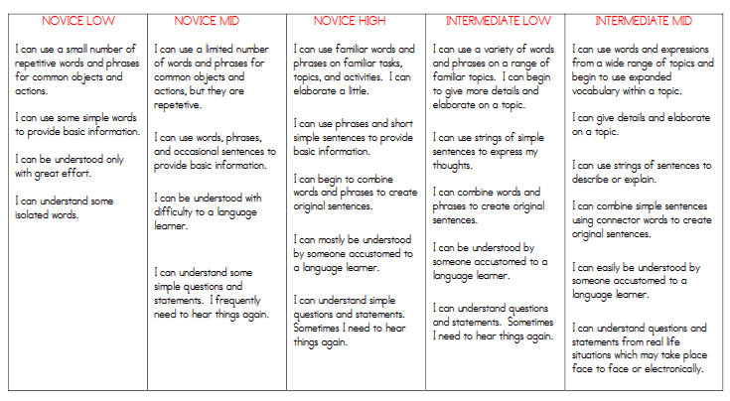
Academic Integrity in regard to translation assistance: The use of translation services and / or devices to create or translate phrases, sentences, or portions of a task will be considered cheating. The goal of the course is for the learner to be able to communicate using the knowledge base he or she has and is gaining throughout the course(s). Evidence of this is found when students use grammatical structures, tenses, and vocabulary that have not been presented in class. However, there is a legitimate use of reference materials that is acceptable, and part of the curriculum is to teach students the difference between the two uses. No credit will be given to students for tasks that have evidence of cheating or the use of translation services. Class notes will provide students with the information they need to complete assignments without needing to utilize outside translation devices.

