_______________’s

Primary Source in 21st Century History



The Coronavirus Pandemic of 2020

By:

_______________________________

________________________________________________________________________________________________________________________________________________________________________________________________________________________________________________________________________________________________________________________

First Fact I Learned About CVOID-19… ___________________________________________________________________________________________________________________________________________________________________________________________________

How I felt, when I heard the news…

Did you think it was real?

YES/NO

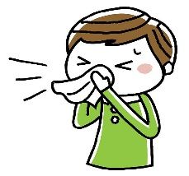

What was the craziest response you heard people have to the news?

___________________________________________________________________________________________________________________________________________________________

Did you respond with fear? Why? ____________________________________________________________________________________________________________________________________________________________

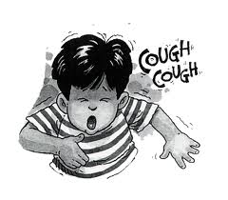

Did your family rush out to buy toilet paper? Did they find any?

______________________________________________________________________________

What did they do? ____________________________________________________________________________________________________________________________________________________________

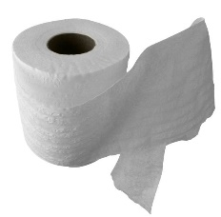

What else did your family struggle to find? ____________________________________________________________________________________________________________________________________________________________

Who was the US President? _____________________________________

He was the __________ US President.



What did you hear him say, during all of this? ____________________________________________________________________________________________________________________________________________________________________________________________________________________________________________________________________________________________________________________________________________________________________________________________________________________________________________________________________________________

Where did you go to school? _______________________________________

What did they do about keeping students healthy? ____________________________________________________________________________________________________________________________________________________________ Was your school helpful in helping you learn, while you were home? Why/Why not? ___________________________________________________________________________________________________________________________________________________________________________________________________

Did they deliver your family food?

Yes/No

If so…How did you get it? _______________________________________

What were the healthy practices that were established and communicated to keep people virus-free, during this pandemic?

|  |  |
| --- | --- |
| Step 1: | Step 2: |
| Step 3: | Step 4: |
| Step 5: | Other: |

Funny Facts You Heard/Read…

1. ____________________________________________________________________
2. ____________________________________________________________________
3. ____________________________________________________________________
4. ____________________________________________________________________
5. ____________________________________________________________________

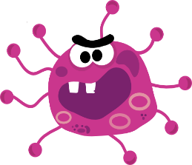

What’s Popular in 2020? ___________________________________________________________________________________________________________________________________________________________________________________________________

What’s good music in 2020? ___________________________________________________________________________________________________________________________________________________________________________________________________

What’s for dinner in 2020? ___________________________________________________________________________________________________________________________________________________________________________________________________

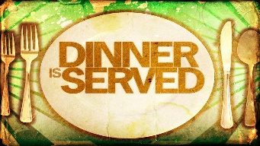

What sports were you playing? ____________________________________________________________________________________________________________________________________________________________

(attach a sports pic of you or someone you know here)

What got cancelled that you missed out on? ____________________________________________________________________________________________________________________________________________________________

How did you feel? ______________________________________________________________________________

(attach artifact of cancelled event(s) here)

How much did 2020 cost?



[This Photo](http://www.undercoverwaitress.com/2011_06_01_archive.html) by Unknown Author is licensed under [CC BY-NC-ND](https://creativecommons.org/licenses/by-nc-nd/3.0/)



Milk _______________________________

Bread _____________________________

Butter_____________________________

Cheese_____________________________

Chocolate Candybar______________

Gasoline___________________________

Oil Change_________________________

Rent________________________________ Mortgage___________________________

Daycare____________________________

Private School_____________________

College_____________________________

Car_________________________________

What did your family do, during the country-wide QUARANTINE? _____________________________________________________________________________________________________________________________________________________________________________________________________________________________________________________________________________________________________________________________________________________________________________________________________________________________________________________________________________________________________________________________________________________________________________________________________________________________________________________________________________________________________________________________________________________________________

Draw a picture of it…

What was your favorite memory you made? ____________________________________________________________________________________________________________________________________________________________



What was your favorite game you played, as a family? ______________________________________________________________________________

What new game did you learn how to play? _______________________________________

Describe it… ___________________________________________________________________________________________________________________________________________________________________________________________________

What new thing did you learn, during this time? ____________________________________________________________________________________________________________________________________________________________

Draw a picture (or include photo) of your family participating in a family activity.

(continued)

If you could have changed one thing, about this time in history, what would it be? ___________________________________________________________________________________________________________________________________________________________________________________________________

What was the most exciting thing? ___________________________________________________________________________________________________________________________________________________________________________________________________

What was the scariest thing? ___________________________________________________________________________________________________________________________________________________________________________________________________

If you could have been the President of the United States, during this time, what would you have done differently? _______________________________________________________________________________________________________________________________________________________________________________________________________________________________________________________________________________________________________________________________________________________________

(Attach 2020 Photo of You Here)

What else was happening in history, current events, during the CVOID-19 Scare?

_____________________________________________________________________________________________________________________

_____________________________________________________________________________________________________________________

_____________________________________________________________________________________________________________________

_____________________________________________________________________________________________________________________

(Attach Artifacts or Newspaper Clippings Here)

(Attach Artifacts or Newspaper Clippings Here)

(Attach Artifacts or Newspaper Clippings Here)

(Attach Artifacts or Newspaper Clippings Here)

(Attach Artifacts or Newspaper Clippings Here)

What was happening in sports, during this time? _____________________________________________________________________________________________________________________

_____________________________________________________________________________________________________________________

_____________________________________________________________________________________________________________________

_____________________________________________________________________________________________________________________

(Attach Sports Articles Here)

(Attach Sports Articles Here)

(Attach Sports Articles Here)

__________________________ Family

2020 Family Photo